**Huda Husain Petkar**

**M. Sc DS AI || L017 || ADBMS**

**Practical - 3**

**Date: 10.01.25**

**Aim: Basic CRUD Operations using MongoDB**

**Q. Create Database**



**Q. Creating a New Collection:**



**Q. Insert Documents**

Insert One

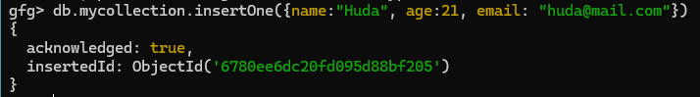

Insert Many

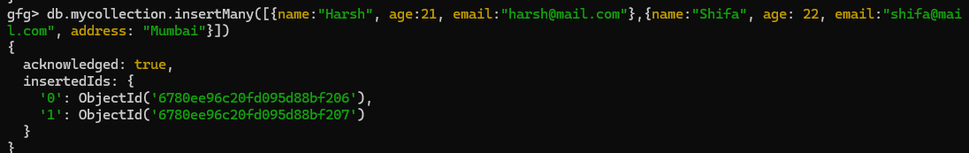

**Q. Show Collection**

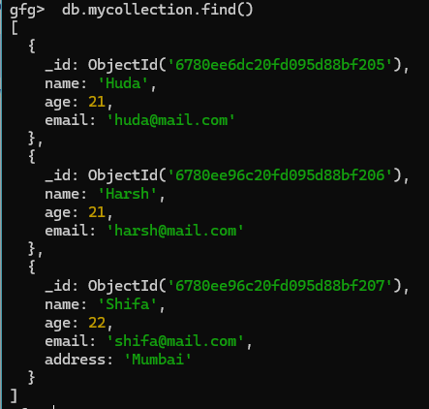

**Q. Find**

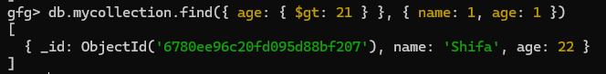

**Q. Find a single record**

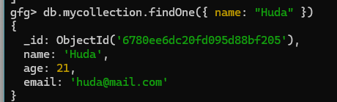

**Q. Update single record**

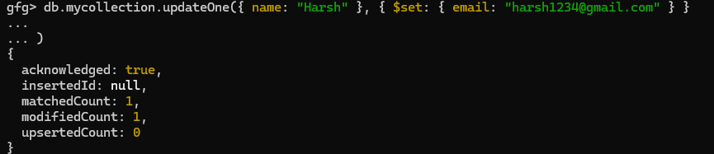

**Q. Update multiple records**

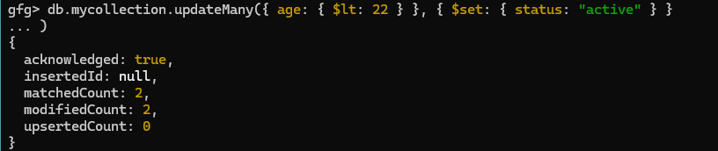

**Q. Delete single record**



**Q. Delete multiple records**



**Q. Delete Collection**

